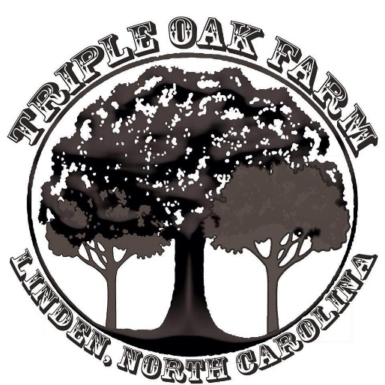

Waiver of Liability
________________________________ is accepted for Lessons and/or Camp on the condition that he/she and parent/guardian fully understand and acknowledge that hazards and obstructions can exist when being involved with horses; including any and all outside influences.
Upon placing my signature on this paper, I hereby acknowledge my full understanding and willingness to accept the risks of injury incident to the above-mentioned activities for myself or for the minor for who I am responsible, and waive Hannah and/or Tylor Mosier, Triple Oak Farm, and/or land owners from any and all liability.
Parent/Guardian Name:_________________________________________________
Signature:_______________________________________________________________
Student Name:__________________________________________ Age:___________
Address:_________________________________________________________________

_________________________________________________________________________

Phone:__________________________ E-mail _________________________________

**Helmets and appropriate footwear are required. No sandals, flip flops, crocs, etc. are allowed. Closed toed shoes only.

Photo Release Form

I give permission for photos of my child _____________________________________
to be taken and posted on the Triple Oak Farm Facebook Page.
__________ YES

__________ NO

Parent/Guardian Name: __________________________________________________

Parent/Guardian Signature:_______________________________________________

